THE DESERTED HOUSE

Descriptive writing

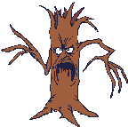  Useful Nouns | Useful Adjectives
Trees  Chimney  Fungi  Cockroaches  Veranda  Cobwebs  Wind  Ivy  Floorboards  Windows  Cellar | Dim  Vivid  Broken  Cold  Strange  Silver  Dusty  Old  Morbid  Eerie

The deserted house

In pairs think of adjectives and nouns you could use to describe a deserted house:

Useful Nouns | Useful Adjectives

